Safety and Recycling Overview

Cleaning Materials for Electronics and Computer Equipment
- Antistatic electronic wipes
- Glass and surface cleaners
- Isopropyl alcohol
- Specialized device cleaning kits
- Compressed air
- Stabilant-22a

Using a Vacuum Cleaner Safely
- Computer-compatible vacuum cleaners have features such as:
- Small tips and brushes
- Antistatic construction
- Adjustable neck

Recycling & Disposal Issues
- Batteries
  - Should not go into landfills
  - Drop-off bins for batteries used to maintain the CMOS and RTC settings
  - Careful disposal of Li-Ion, Ni-Cad or alkaline batteries
- Toner & Printer Cartridges
  - Return to manufacturer
- Chemical Solvents & Cans
  - Recycle citrus-based and other mild cleaners
  - Careful disposal of toxic material
- Obsolete monitors and other computer equipment
  - Recycle

MSDS
- Material Safety Data Sheet (MSDS) used to determine
  - Safe storage practice
  - Treatment if the product is accidentally swallowed or contacts the skin
  - Safe disposal methods
  - How to deal with spills, fire and other hazards

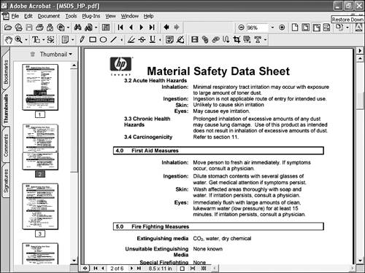

Electro-Static Discharge (ESD)

- ESD is the static-electricity discharge that happens when two differently charged objects (such as your body and a computer component) come in contact with each other

- Known as an invisible killer of computer components because ESD build-up and discharge can happen long before you actually notice it

- As little as 30V of ESD is enough to destroy the current generation of low-powered chips.

- You can build up 20,000V of ESD from walking across a carpeted room (in Winter if you shuffle)

- “Invisible” because it leaves in its wake equipment that has no visible damage but won’t work reliably.

- ESD is a major cause of intermittent failures

- Preventing ESD
  - You can prevent ESD by taking proper precautions when you do the following
    - Install or remove components
    - Store and transport components
    - Use computers
  - Unequal electric potential between you and the device on which you are working is a major cause of ESD. When you body has a higher electric potential than the device, and ESD from your body to the device equalizes the potential – but at the cost of damage/destruction to the device.
- Prevention Devices
  - Antistatic work mat
  - Antistatic wrist strap
  - Antistatic carpet spray
- Goals of correct storage of equipment:
  - Eliminate the possibility of ESD
    - Faraday cage antistatic bags
  - Protect equipment from impact damage
    - Store components in appropriate boxes to avoid physical damage

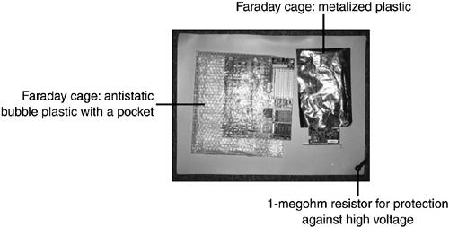

- Additional Precautions:
  - When you must handle devices with chips attached do not touch the chips
  - Hold expansion cards by the brackets, never by the motherboard connections
  - Wear natural fibers, instead of synthetics to avoid ESD buildup
  - Use antistatic spray to treat carpeting to reduce EDS
  - Use antistatic wipes
  - If you use a liquid cleaner, always spray the cloth, never the device

Hazards

- Computer equipment hazards for the technician:
  - High voltage sources, such as computers, and peripherals, such as printers and monitors
  - Mechanical devices such as printer mechanisms
  - Laser-light sources, such as laser printers and optical devices

High-Voltage Sources

- Printers

- Power Supplies

- Monitors

- Systems in suspend mode

- Printers
  - Unlike computers, printers do not usually run on safe, low-voltage DC (direct current). Although laser printers typically do use DC current, it is at a high voltage. Most dot-matrix and inkjet printers also use high-voltage AC (alternating current)
  - Defeating safety features that shut off the laser printer can put you in risk of a shock or a zap in the eye from a laser beam
  - Dot-matrix and inkjet printers can pinch or crush fingers in their gears and paper feeders
  - Always turn off and unplug printers before servicing them
  - Water should not be used to clean up ink/toner spills unless the printer is turned off and disconnected, due to the risk of a potential fatal electric shock

- The Power Supply
  - Never remove the case under any circumstances

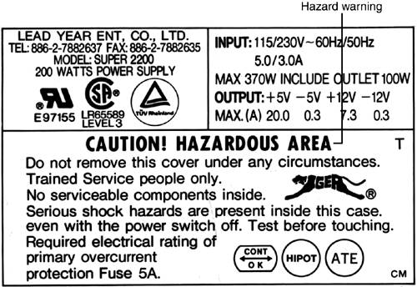

- Monitors
  - If you remove the cover you expose danger
  - In this course we will not remove the cover of monitors

- Systems in suspend Mode
  - ATX and NLX systems can go into a suspend mode rather than a true “off” condition when shut down by Windows.
  - As with other devices, the power can still be on unless you disconnect it at the source

Protection against Electric Shock

- Remove jewellery. Metal jewellery provides an excellent path for current.
- Use rubber gloves to prevent your hands from touching metal parts for extra insulation. However they do not provide enough insulation to allow you to work on a live system.
- Work with one hand out of the system, to avoid electricity passing through your chest if your arms complete a circuit
- Keep dry

Disconnecting Equipment

- Printers, computers, monitors should be disconnected from power as well as turned off before service. This will prevent shock hazards as well as mechanical hazards
- Do not leave the computer plugged while you work inside it.

